Part 1

Javier Parada

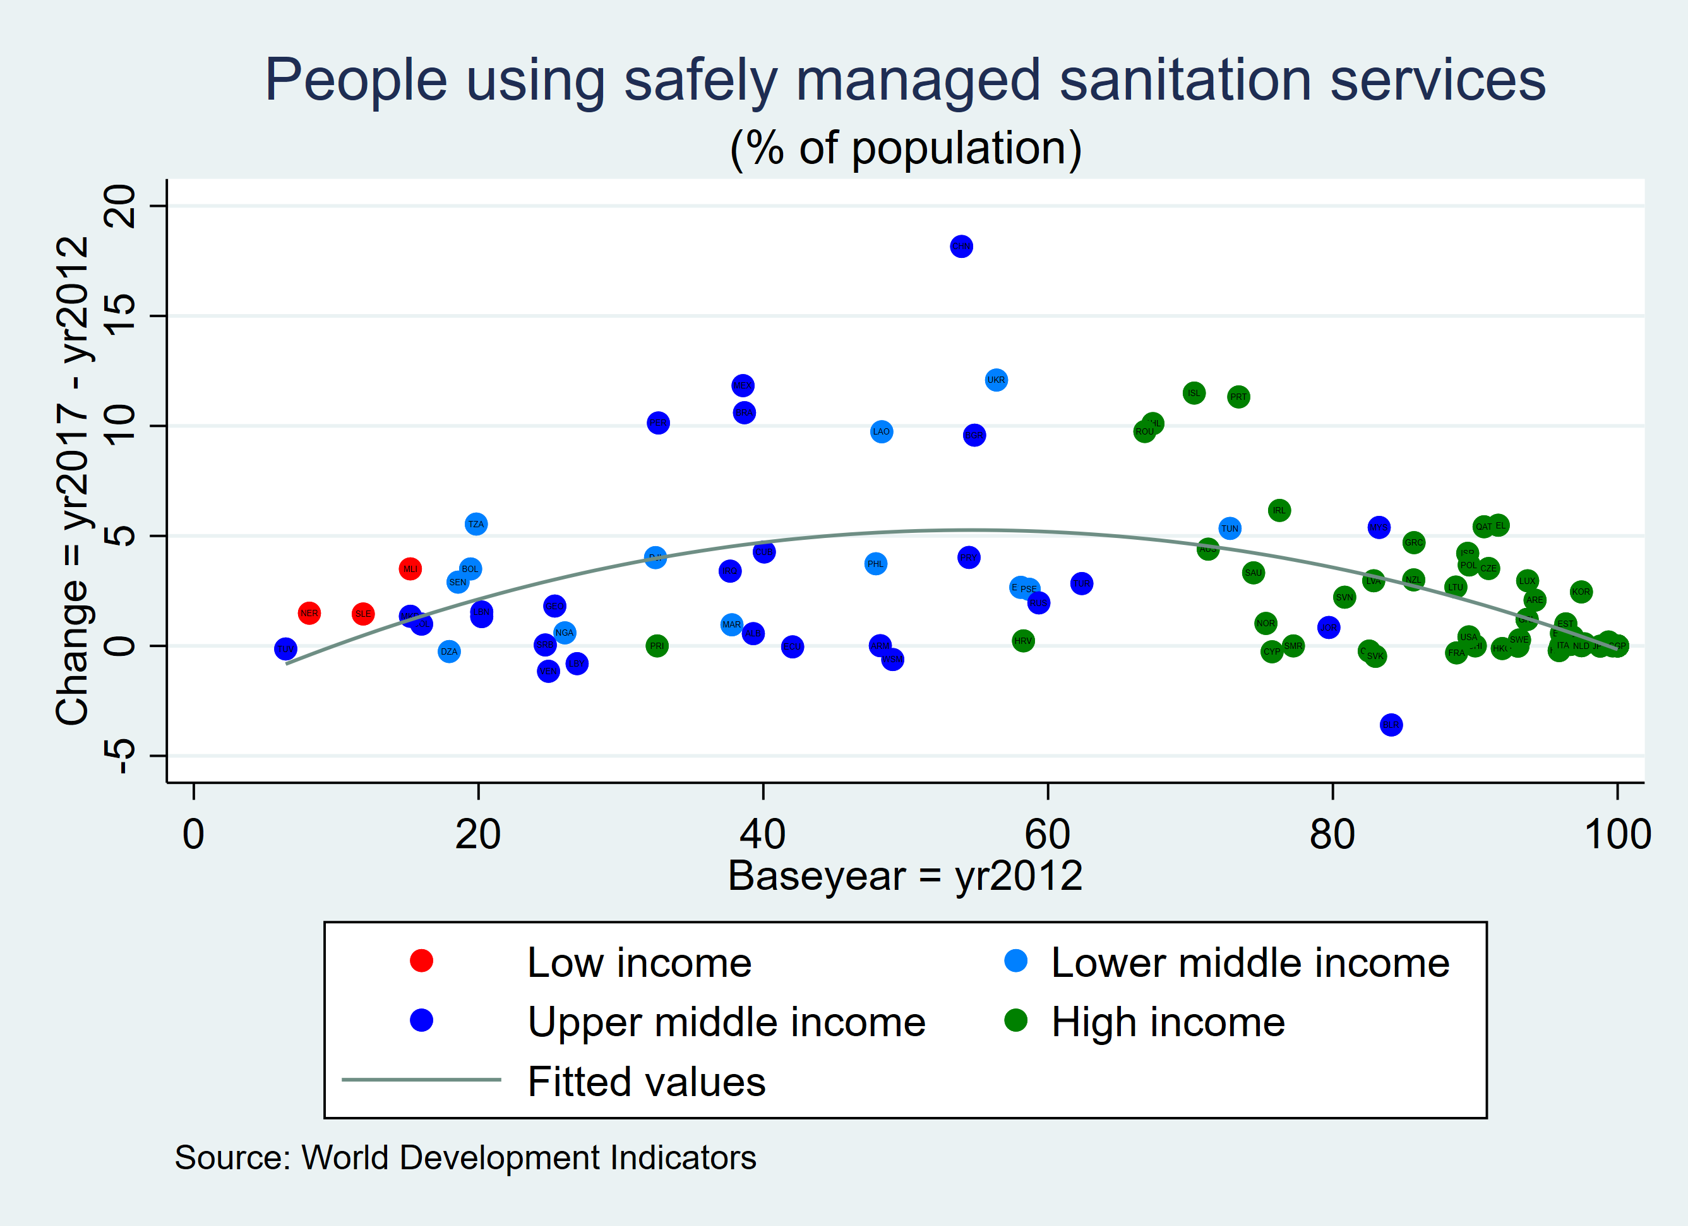

**Figure 1:** This figure shows people using safely managed sanitation services as a percentage of the total population in the x-axis for the year 2012 Access to sanitation facilities is increasing over time in most countries, it is not doing so in an even way that will allow to reach max coverage. Low income: Niger (8%), Sierra Leone (12%), Mali (15%) have barely increased. Upper Middle Income; Belarus, Venezuela, Libya China +18% . High income countries have reached the maximum such as Monaco, Kuwait, and Singapore